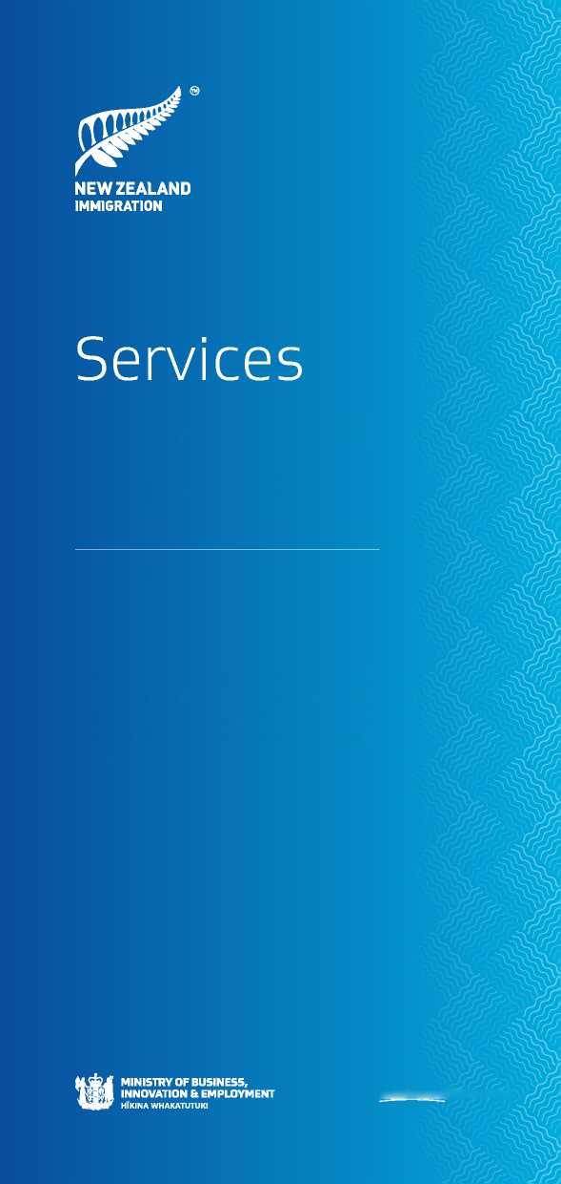

AUCKLAND

**NewZfealand Government**

This brochure contains information about services and support that are available to persons seeking refugee or protected person status in New Zealand (known as “asylum seekers”).

for Asylum

Seekers

EDUCATION

**English lessons**

You may apply to attend English language classes. There are many organisations that teach English language courses, including tertiary institutions, secondary schools, home tutors and community education centres. You may have to pay a fee to attend these courses.

If you are issued a work visa while your refugee and protection claim is being processed, permission is given only to attend English as a second language course and not for any other courses.

For more information see The Tertiary Education Commission [www.tec.govt.nz](http://www.tec.govt.nz) (search for “ESOL students”) and/or English Language Partners <http://englishlanguage.org.nz/>

**Primary and secondary schools**

All children between the age of 6 and 16 must attend school in New Zealand. Asylum seeker children will generally be issued a student visa.

HEALTH

New Zealand has a public health system that provides subsidised health care. Asylum-seekers are eligible for this.

The cost of a doctor's visit varies depending on your age, location and personal circumstances. Doctors visits are free for children under 6 years of age.

**You must take the letter from RSB confirming you have lodged a claim for refugee and protection status with you to the clinic or hospital in order to receive subsidised health care.**

Hospitals and public health services will provide an interpreter if needed. You must contact them in advance..

**Urgent medical care**

In an emergency call 111 by telephone for an ambulance to take you to hospital, or you can go directly to the hospital closest to your home.

**Public health screening**

**You are strongly advised to obtain a free public health screening.** To arrange an appointment, contact the centre below. Interpreters will be provided.

**Auckland**

Refugee Health Screening Service

Phone: 09 276 6719

It is recommended that you obtain the free public screening, but note this is not an immigration medical.

SUPPORT AGENCIES

There are a number of agencies which offer support services that asylum-seekers can access.

**Auckland Refugee Council Incorporated**

Provides accommodation and support services for asylum­seekers.

Website: <http://aucklandrefugeecouncil.org/>

Email: [arci.refugee@xtra.co.nz](mailto:arci.refugee@xtra.co.nz),

Phone: (09) 378 7434

**Refugee Council of New Zealand**

A national organisation which provides advice, information and assistance to asylum-seekers.

Website: <http://www.rc.org.nz/index.html>

**Auckland Regional Migrant Service**

Provides information and advice, referral to other community groups and organisations for support.

Website: <http://www.arms-mrc.org.nz>

**Refugees As Survivors**

Offers counselling and/or body therapy for victims of torture:

Website: <http://www.rasnz.co.nz/>

Email: [admin@rasnz.co.nz](mailto:admin@rasnz.co.nz)

Phone: 0800 4 72769

**Community Law**

Provides free initial legal help to resolve legal problems.

Website: <http://www.communitylaw.org.nz/>

**Citizens Advice Bureau**

Provides free information, advice and support.

Website: <http://www.cab.org.nz/Pages/home.aspx>

**New Zealand Red Cross**

The New Zealand Red Cross has a range of support services for refugees and asylum seekers including a pathways to employment programme, which some asylum seekers can access. See [www.redcross.org.nz](http://www.redcross.org.nz)

**CONFIRMATION OF YOUR STATUS IN NEW ZEALAND** You will receive a letter from the Refugee Status Branch (RSB) confirming that you have lodged a refugee and protection claim in New Zealand.

**It is very important that you keep this letter and take it with you when you visit other government agencies, health and education providers, and service providers.**

**If necessary the RSB can confirm your status as an asylum seeker directly with the government agencies listed in this brochure. Agencies can call the RSB on: (09) 928 2236 or email: [RSB@mbie.govt.nz](mailto:RSB@mbie.govt.nz)**

INTERPRETING SERVICES

**Language Line**

Language Line is a telephone interpreting service which is available Monday to Friday 9am-6pm and Saturday 9am-2pm. You can use Language Line when speaking to government agencies, including: Immigration, Inland Revenue, Internal Affairs, Education, Work and Income, Career Services and the Police. To use Language Line visit or telephone the government agency you need and ask for Language Line and the language you want. For more information and a full list of participating agencies see:

Website: [www.languageline.govt.nz](http://www.languageline.govt.nz)

Free phone: 0800 656 656

IDENTITY DOCUMENTS

To access services, you may need an identity document (ID). Usually, a passport is sufficient to establish your identity with most organisations.

**Certificate of Identity**

If you do not have a passport, you will need to obtain a Certificate of Identity (COI) from an Immigration New Zealand (INZ) branch. A COI is a document issued by INZ that will have your photograph and biographical details such as your name and date of birth. INZ can issue a visa into a COI. Other agencies such as Work and Income and banks will also accept a COI as proof of identity.

To apply for a COI make an appointment to visit your nearest INZ branch. You can find a list of branches on the INZ website: [www.immigration.govt.nz](http://www.immigration.govt.nz)

RESIDENTIAL ADDRESS

Most government agencies and service providers (such as banks, electricity and telephone companies) require proof of your residential address. This can be an official letter addressed to you - for example, RSB's letter confirming you have lodged a claim. If you do not have an official letter with your correct address on it, you can ask RSB for one.

**Accommodation**

If you need to find accommodation, many local newspapers advertise rental accommodation - either a “flat” or a room in a shared house. Trademe ([www.trademe.co.nz](http://www.trademe.co.nz)) also has rental accommodation. Your local supermarket, library or community centre may have a noticeboard where people advertise rooms or flats. Real estate agents and letting centres can help you find accommodation. They will charge for this service. If you are struggling to find accommodation contact Work and Income: [www.workandincome.govt.nz](http://www.workandincome.govt.nz)

BANK

You will need to open a bank account for tax purposes and to receive wages and income. Most banks require:

* **two forms of ID** such as a passport and a driver's licence or birth certificate, and
* **proof of your address** such as a letter from a government agency or service provider (electricity company for example).

Visit your local bank or one near your work to open an account.

INLAND REVENUE

To work in New Zealand, or to receive support from Work and Income, you need a tax number from Inland Revenue (IR).

To obtain an IR number complete an IR595 form. To obtain a copy of this form, telephone 0800 257 773 or download it from: www. ird.govt.nz/how-to/irdnumbers. Take the IR595 form to your nearest IR office with your passport and proof of your address. Your documents will be verified and IR will issue you with an IR number.

Website: [www.ird.govt.nz](http://www.ird.govt.nz)

Free phone: 0800 377 774

EMPLOYMENT

If you are issued a work visa while your refugee and protection claim is being procesed you are able to work in New Zealand.

**Websites**

Most jobs are adversited online and there are a number of useful websites where you can search for jobs according to region, type, and your skills and qualifications. Some popular websites are:

[www.seek.co.nzwww.trademejobs.co.nz](http://www.seek.co.nzwww.trademejobs.co.nz)

**Newspaper**

Jobs in newspapers are usually called “situations vacant” and appear in the classified advertising section of newspapers such as:

The New Zealand Herald - [www.nzherald.co.nz](http://www.nzherald.co.nz)

**Government agencies**

Career Services and Work and Income can assist you with practical advice to help you find a job, such as workshops, training opportunities, job listings, job search skills and writing a curriculum vitae (CV). Visit their websites:

Career Services: [www.careers.govt.nz](http://www.careers.govt.nz)

Work and Income: [www.workandincome.govt.nz](http://www.workandincome.govt.nz)

FINANCIAL SUPPORT

If you have a valid and current visa you may be eligible to receive an Emergency Benefit from Work and Income while your refugee and protection claim is being processed.

You will need to contact Work and Income to make an appointment to see a case manager at the branch closest to where you live.

For more information visit your local Work and Income office, or phone them on: 0800 559 009, or go to their website: [www.workandincome.govt.nz](http://www.workandincome.govt.nz) If you speak little or no English, Work and Income provides information in other languages:

* Mandarin - 0800 661 001
* Cantonese - 0800 664 004
* Hindi - 0800 993 003
* Farsi - 0800 996 006
* Arabic - 0800 668 008
* Khmer - 0800 994 004
* Somali - 0800 997 007
* Punjabi - 0800 995 005
* Vietnamese - 0800 665 005

There are many places where you can find work, such as newspapers and online.